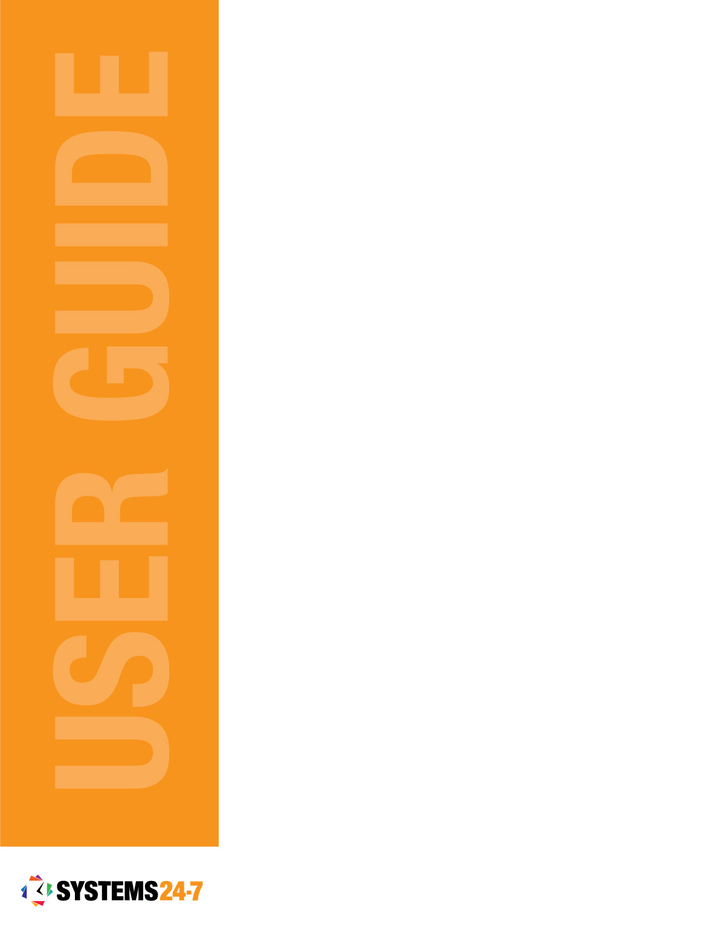
Report It
Administration Section

Table of Contents
Build a New Report 5
Report Builder Overview 6
BUILD AND THEME 7
CHANGING THE THEME 7
PREVIEWING AND SAVING YOUR REPORT 7
Adding a Page to Your Report 8
Edit a Page in Your Report 8
Delete a Page in Your Report 9
Report Tools 9
TEMPLATE LIBRARY 9
ADD ELEMENT 10
PRESET FORM ITEM 13
ADD QUESTION TYPE 15
WIDGETS 18
Adding an Element, Form Item, Question Type or Widget 20
Moving an Element, Form Item, Question Type or Widget 20
Copy an Element, Form Item, Question Type or Widget 21
Deleting an Element, Form Item, Question Type or Widget 21
Manage Reports 21
Edit a Report 21
Preview a Report 22
Duplicate a Report 22
Publish a Report 23
Unpublish a Report 23
Activate a Report 23
Inactivate a Report 24
Delete a Report 24
Set-Up Equivalent Reports 24
Manage Equivalent Reports 25
Update a Report 26
View Summary 26
Edit Report 27
Delete a Submitted Report 28
Print the Report 28
Save a PDF of the Report 29
View Report Progress 29
Complete Pending Items 31
Complete an Assigned Task 31
Complete a Task Follow-Up 32
Verify a Report 33
Manage Employee Injury Status 34
Add an Injured Employee 34
Update an Employee’s Injury Status 35

As an Administrator for your company, you can manage the Report It program. The Report It program allows you to create custom reports/forms on the system that can be filled out and submitted by your employees.
To access Report It, we start off with accessing the administration section via the Admin button at the top right-hand corner of your website. If you do not see this button, you may not have the proper administration privileges in the system.
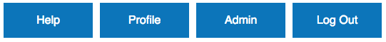
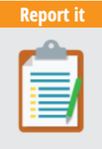
Once you are in the Administration section, click on Report It to see the Report It functions.
The Report It functions are divided into two sections: General Options and Report Administration Options.
Most General Options are available to all users and are used to submit existing reports and complete tasks for pending reports. For detailed information on how to use these options, please refer to our Report It – Basic User Guide.
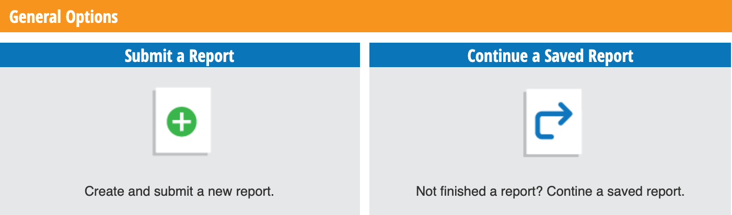
Report Administration Options are the administrative functions for creating and editing reports/forms that can be filled out and submitted by employees.
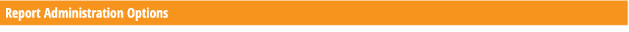
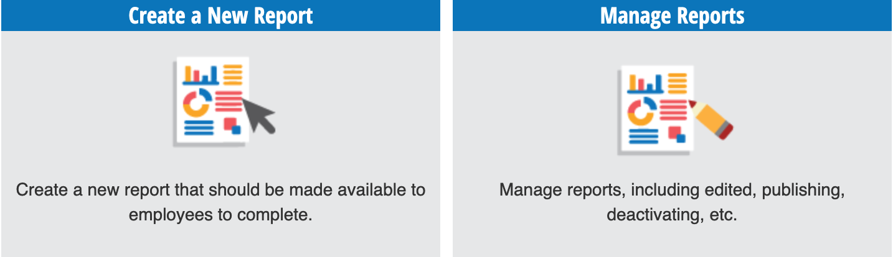
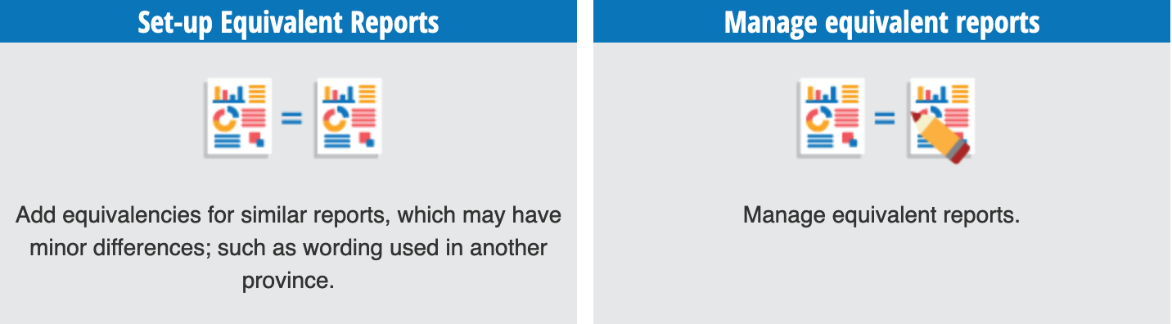
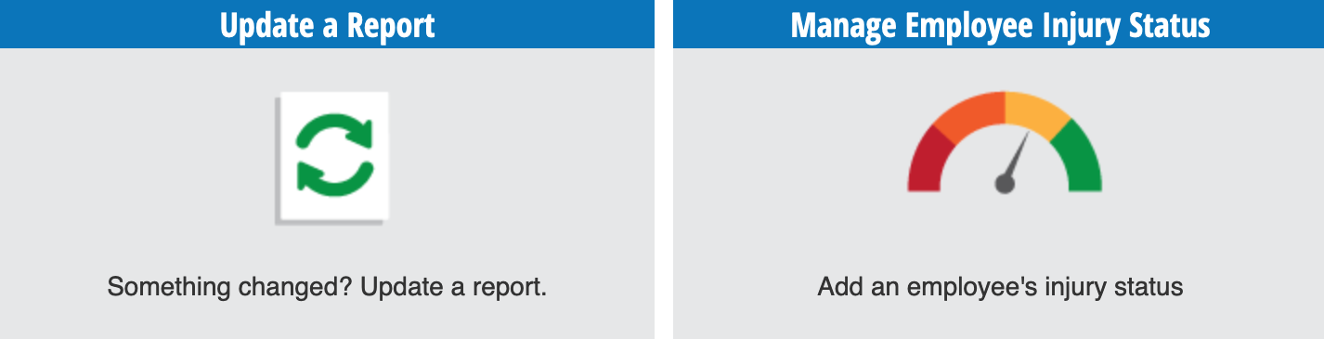
This user guide will walk through the Administration Options in detail and provide step-by-step instructions, along with helpful tips to get the most out of your Report It program. Let’s start by selecting Build a New Report to create a new report.

Build a New Report
To build a new report, you will need to start by determining the high-level settings of the report. First, choose the report type (this is where the report/form will appear below) and enter a name and description for the report. The report description is for your records so you know what it’s for.
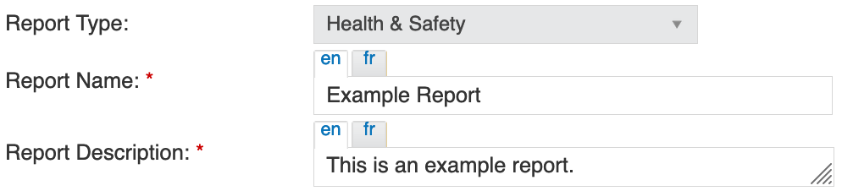
Next, you can add an opening and submission confirmation message. The Opening Message will appear when the user opens the report, and the Submission Confirmation Message will appear upon completion of the report.
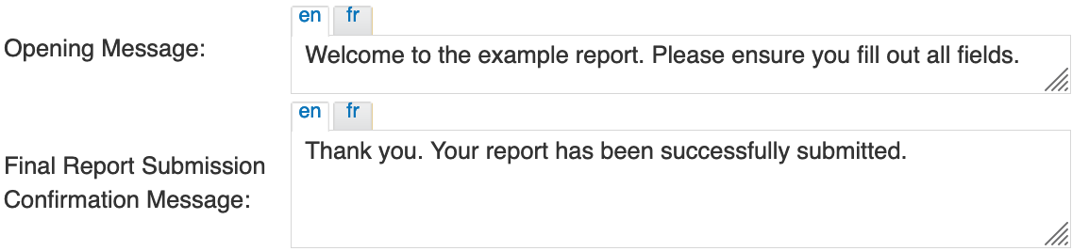
You can set the report to be assigned to a specific administrator level after it has been submitted. The administrator level selected will be notified when the report is fully completed.
You can require verification of a completed report. This means the administrator selected above must verify the contents of a report submitted by a user before the report is closed.
The Add Publishing Frequency field allows you to set restrictions on how often users can submit this report. You can set this to be within a specific time frame, by a fixed date, or by a fixed yearly date. In this example, we have allowed users to submit this report once per day.
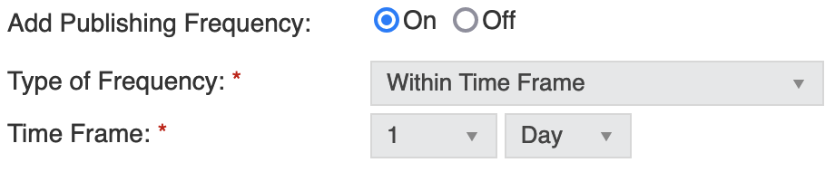
If the Enable Logon Reminder field is turned on, a popup message will appear when the user logs on to remind them of any pending Report It items to be completed.
Use the Assignment field to determine which users can view and submit this report/form. By default, published reports are visible to everyone, but you can assign them to certain groups of employees. For example, if a report/form is only relevant to a manager, you may wish to assign it to the specific administration level. Reports can be assigned in the following ways:
- Everyone in the company
- Certain Groups
  - Users within a specific level of the Company
  - Users who have a specific Category assigned to them
  - Users in a specific level of the company with a specific category assigned
  - Administration Level
  - Specific Users
You can set whether a completed report will be saved under the current user or current user location. This determines which users can see this report under the View Report Progress function after it has been closed. Current User means that the report is saved under the user submitting the report. Current User Location means that the report is saved under that user’s location. A report saved in this way remains under this location and is visible to any users under that location.
You can also determine if a report can be updated after it has been submitted. If this setting is enabled, administrators can update a submitted report at any time.
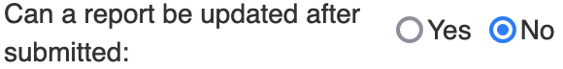
Once you have made all your selections, click Create Report to start building your report.

Now it’s time to build the actual report! After selecting Create Report, you will be taken to the Report Builder page. Let’s walk through each report element so you can build a custom report to fit your organization's needs.

Report Builder Overview
The report builder feature has a wide variety of tools and options that you can use to build your report. These include templates, elements, pre-set forms, questions, and widgets.
There are also options for adding multiple pages to your report, customizing the themes of different elements, and previewing the report.

BUILD AND THEME
When in the report builder, the page will default to Build mode, but you can toggle between Build and Theme by using the tabs in the top right-hand corner of your screen.
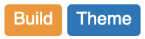
Build is where you will develop your report and add all your content and fields.
Theme is where you can customize the look and feel of the report to match your company’s brand standards and help differentiate between the different sections of your report. This tab allows you to change the font, font size, and colour of the text.

CHANGING THE THEME
Under the theme tab, you can change the font, font size, and text colour for the following settings:
Section Settings: This controls the text in any Section elements added to the report.
Option Settings: This controls your Options Added text when creating an open question type for radio, dropdown, and checkbox fields.
Text Settings: This controls the text in the Text Area element under the Add Element section.
Question Settings: This controls the question/comment for all Question Types added to the report.
Widget Settings: This controls the text “Add Another” when using the Add Another widget.
After you have made all your selections, click Save.

To test your changes to the report’s theme, select the Build tab and then click Preview Page.

PREVIEWING AND SAVING YOUR REPORT
In the bottom right-hand corner are the Preview Page and Save Report buttons. Make sure you save your report frequently to avoid any loss of work.

Note: Saving your report does not make it accessible for use. After building your report you will need to publish it to use it. See the Publish a Report section of this user guide for step-by-step instructions.
As you build your report you can click on the Preview Page button to see how each element will function from a user’s perspective. This can be helpful when adding hints, restrictions, or options to assign specific fields to other users.
To exit the report preview, click the Close Preview button in the top right-hand corner of the pop-up window.
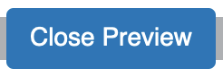

Adding a Page to Your Report
By default, you will start on Page 1 of your report. You can build a one-page report or break your report into multiple pages.
To add a page to your report, click on the Add Page icon found at the top of your screen next to the “Page 1” tab.

Name your report and make your visibility selection. You will see visibility come up on most elements when building your report. Here is a breakdown of your options:
Everyone: Anyone filling out the report will have access to this page.
Certain Groups: Assign this page to a company level or specific user.
Hidden Page: This will give you the ability to reference this page when triggered by a specific question’s response in the report.
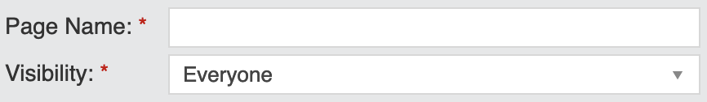
If this page of the report requires verification or review, you can select which admin or user is notified upon completion of this page.
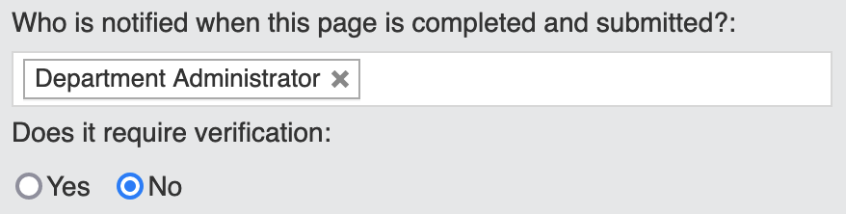
Once you’ve made your selection, click Add.
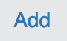

Edit a Page in Your Report
To edit the settings of a page in your report, select the gear icon in the page tab (shown below).

Make your changes and click Save.

Delete a Page in Your Report
To delete a page in your report, select the ‘X’ icon in the page tab (shown below).

The system will ask you to confirm if you want to delete the page. Select Delete to complete your action.
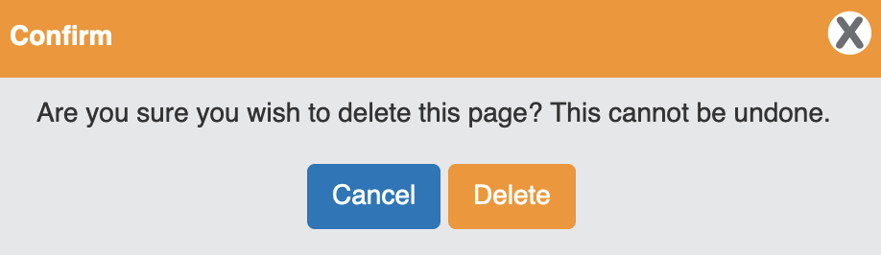

Report Tools
In this subsection, we will walk through all the elements, form items, question types, and widgets in your report tools menu. Let’s start at the top and work our way down.

TEMPLATE LIBRARY
The template library is a list of templates or samples of existing reports that you can use as a starting point for your report. You can use one of these templates and modify it as needed or create your report from scratch. To see the library of templates, click the Add From Library button in the left-hand tools list.
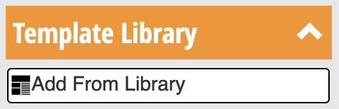
This will open the list of samples. You can use the search field to look for a report that meets your needs or scroll through the list.
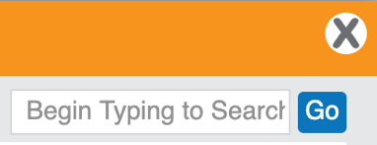
Choose a sample from the list and click the Add button. If you don’t see a report sample that matches what you are looking for, click Create New.

Once you click Add, the sample will populate in the report builder, and you can make any changes and additions as needed. Let’s dive into the Report Tools menu.

ADD ELEMENT
Elements are static items in the report that are not affected by the user submitting the report. These include sections, text areas, images, lines, spacers, and tables.
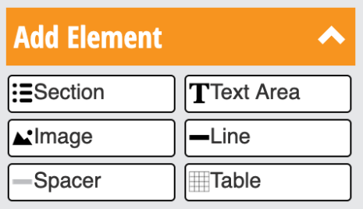
Sections are used to divide pages into areas of content. To add a section, click the Section button in the Add Element list. Enter a name for the section and click Add.
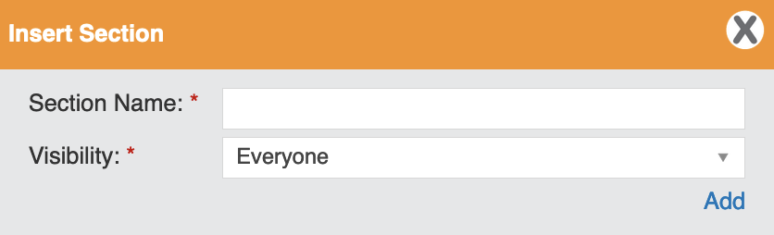
The Visibility field allows you to change who can see the item – this field is available to use with all element types. You can set the visibility of an element to everyone, to a certain group, or as hidden. Hidden means that the item is not visible to anyone until a specific action has been triggered while submitting the report. For example, if a user selects “Yes” to a question and more details are needed, a follow-up question can appear but only if the user answered “Yes”.
The Text Area element can be used to insert lines of instructional text in your report. Type in the text that you need and click the Add button.
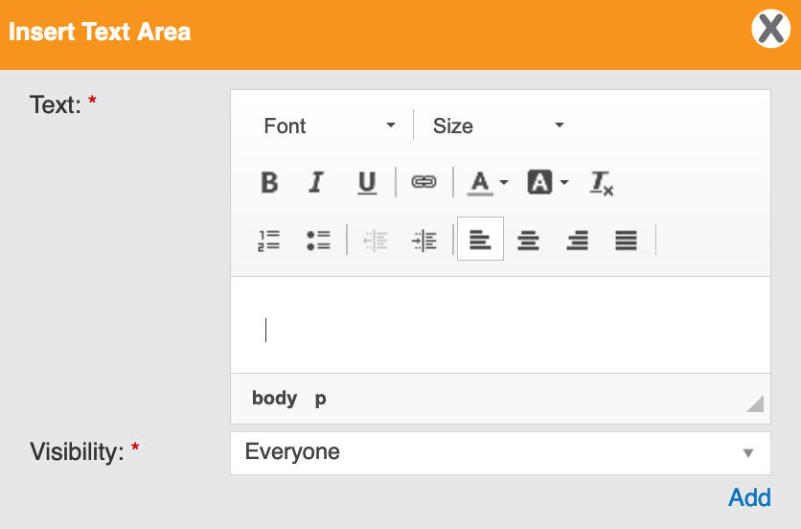
Use the Image element to insert images into your report. Click the Select File button to locate your image.
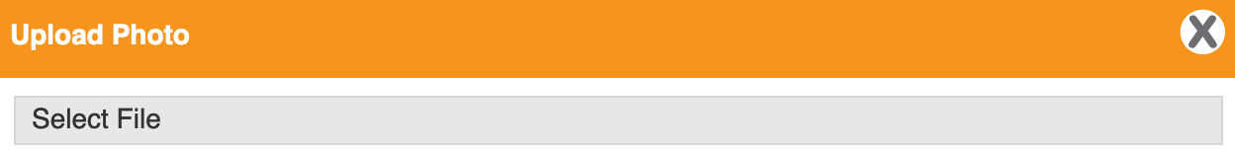
If you need to upload an image from your computer, click on the Add file button located at the top of the pop-up window.
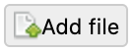
Select “Browse…” and locate your image file(s). You can upload more than one image at a time.
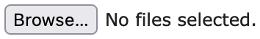
After you have uploaded your image(s), click the Cancel button. Double-click on the image you want to add to your report. The image height and width will auto-fill, but they can be adjusted manually.
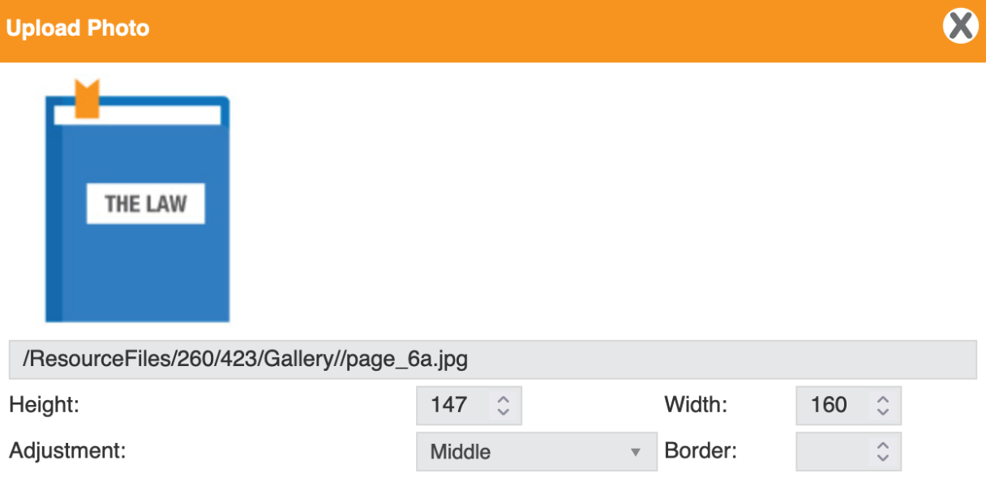
Here is a breakdown of your image settings and controls.
Height and Width: This allows you to adjust the size of the image.
Adjustment: Choose to align your image to the top, middle, or bottom of the image block.
Border: Add a border around your image by selecting the line thickness.
Image Hyperlink: This allows you to link a URL to the image. If you wish to have the link open in a new tab, select “Open Link in a new Tab”.
Alt Text: This allows you to add descriptive text to your image. This is important for accessibility purposes and screen reading devices.
Advisory Title: This allows you to add a message to the image. When a user hovers over the image, the advisory title will appear.
Once you have made all your selections, click Add.
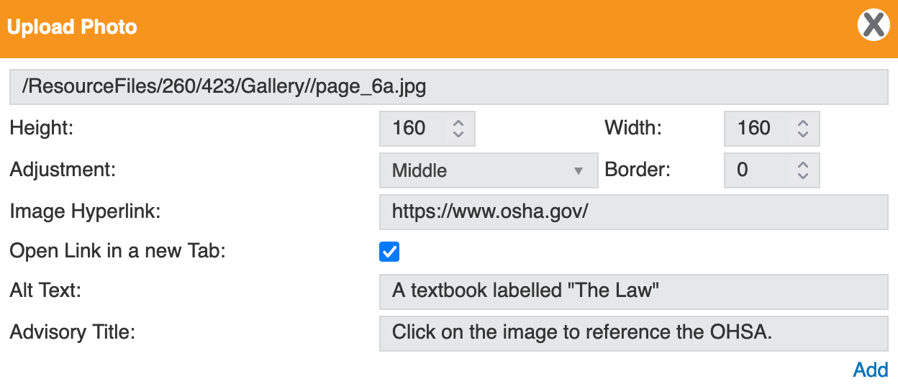
Use the Line element to insert a full-page line into your report. This element can be great to break up different sections of your report.
Line Style: Choose from three-line styles – Solid, Dashed, or Dotted.
Line Colour: Choose from an existing colour swatch or enter a unique HEX code.
Line Thickness: This allows you to determine how bold the separation line displays.
Visibility: This allows you to determine who sees the line. You can choose from everyone, certain groups, or hidden questions.
Once you have made all your selections, click Add.
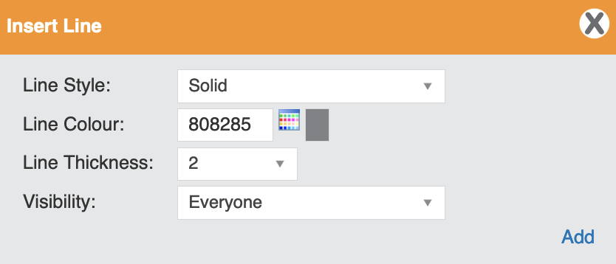
Use the Spacer element to add additional space between elements such as text, section, or image. You can increase the space by changing its thickness.
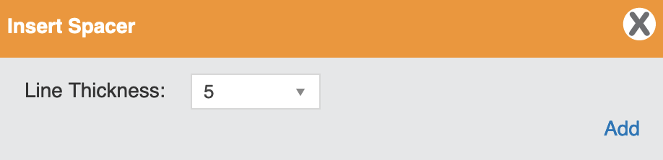
Finally, the Table element. This gives you the ability to add a table to the report. Determine how many rows and columns you need and then customize the design elements.
Line Style: Choose from three-line styles – Solid, Dashed, or Dotted.
Line Thickness: This allows you to determine how bold the table lines display.
Cell Spacing: This adds space around the outside of the cell.
Cell Padding: This adds space around the inside of the cell.
Line Colour: Choose from an existing colour swatch or enter a unique HEX code.
Visibility: This allows you to determine who sees the table. Is it visible to everyone, certain groups, or does it only appear if triggered by a specific question?
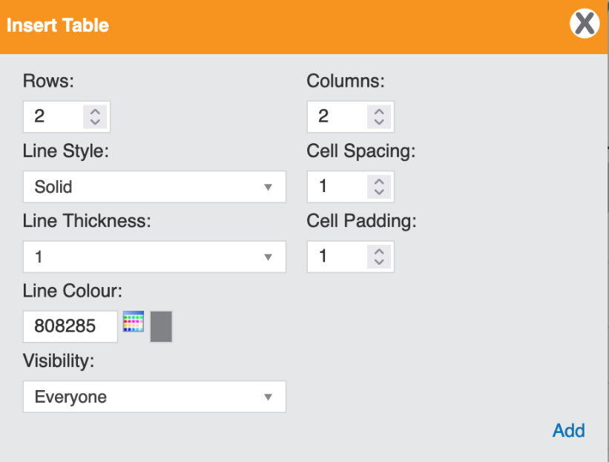

PRESET FORM ITEM
This section consists of auto-filled items. If added to the report, they will pre-populate with data based on the user that is filling out the report. No action is required, the system will pull the information needed from the user’s profile.
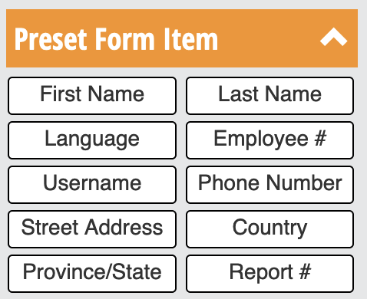
Almost all the form items work the same so we will use First Name as an example and then dive into the exceptions in more detail.
Auto-filled: If “Yes” is selected, the system will auto-fill the field. If “No” is selected, the user will be required to manually insert the information required.
Response Mandatory: If “Yes” is selected, the form cannot be completed until the field has been filled in. If “No” is selected, the field can be left blank and will appear as “Unknown” when submitted.
Edited by an Administrator: If “Yes” is selected, the administrator can change information on the form after responses have been submitted. If “No” is selected, the field will be “locked” after submission and cannot be changed.
Only Viewable by Company Administrators: If “Yes” is selected, only the administrator will see the responses to these form field inputs. If “No” is selected, the entire report will be viewable by all parties involved.
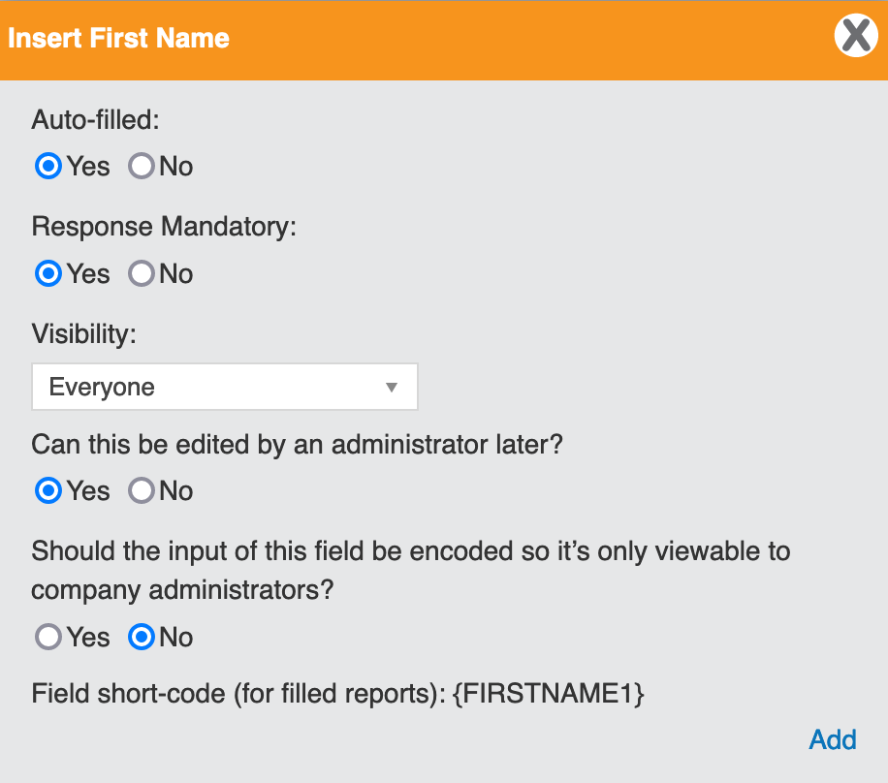
The Select User form item works the same as above, but it gives the user the ability to add someone else to the form using a dropdown menu vs auto-filling to their own information.
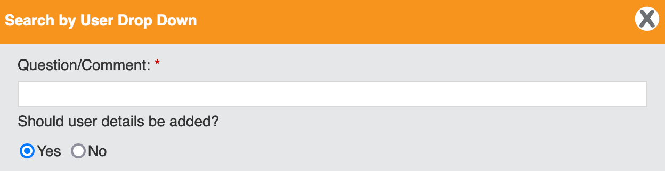
Simply enter your question or comment that requires a user selection. If you would like specific details about that user added to the report, you can select “Yes”. This will give you the opportunity to select which information will be pulled from the system for that specific user.
Use the dropdown menu to select your Pre-set Form Items and select Add Option.
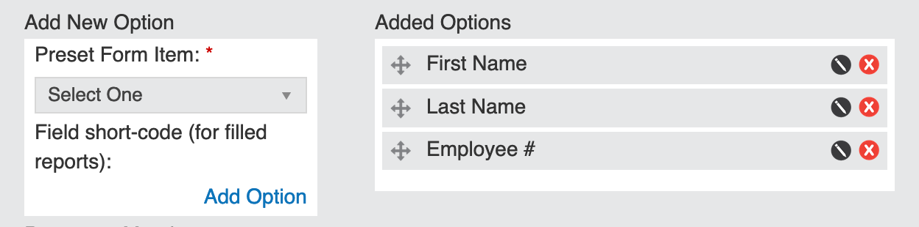
This is how it will appear when completing the report:
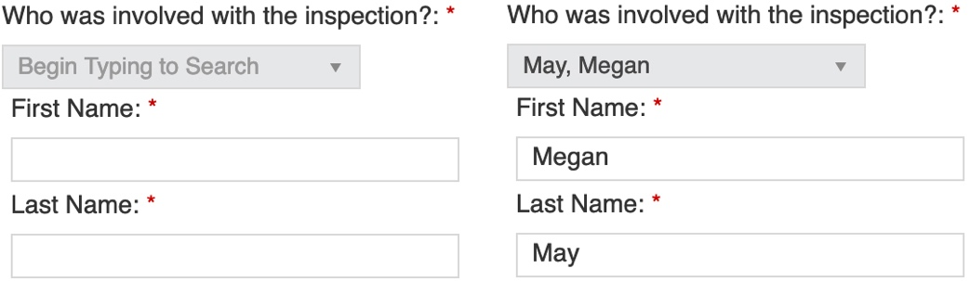
The last Pre-set Form Item that is different is the Filled Item. This allows you to pull information from the report that has already been inserted. Use the dropdown to select a question or comment from the report. Choose whether to display the original question with the response and the system will populate that information where this item is located.
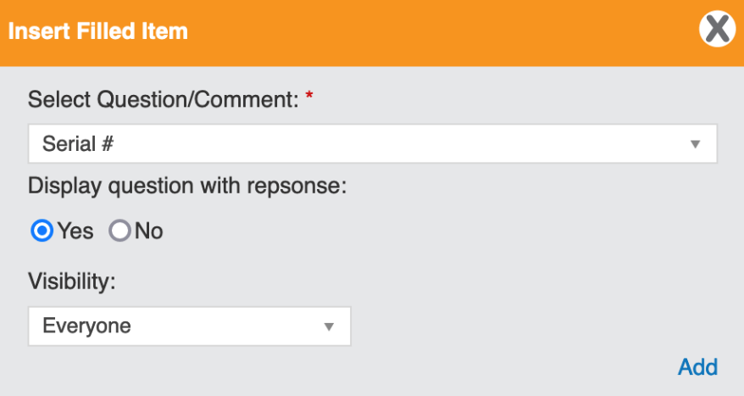

ADD QUESTION TYPE
This section consists of different types of questions such as radio button style, dropdown menus, file upload, and more. Let’s walk through each question type and how they function.
Radio, Dropdown, and Checkbox all work in a similar way. Start by inserting your question or comment. Select whether you want to provide a hint to the user. A hint is a useful way to provide additional information that will help the user complete the field.
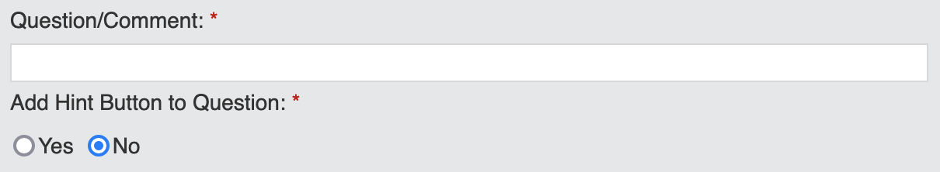
Next, add the answer options by filling in the Option field and selecting Add Option.
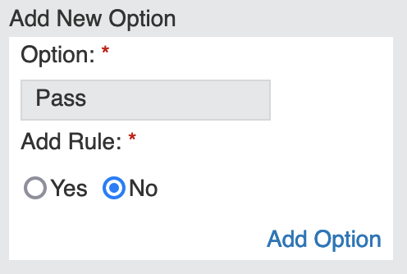
You can add a rule to any option. A rule allows you to trigger another action based on the user's response. For example, if a user selects “Yes”, it could trigger a follow-up question for more information or skip a section on the form.
Here is the breakdown for each Rule Function:
Go To: This allows you to jump to a specific page, section, or question in the report.
Stop: This will force the users to stop filling out the report. You can add a message for further information such as speaking with a manager or supervisor.
Trigger Email: This will allow you to set up an email and select which type of administrator(s) will receive the email.
Trigger Lost-Time or Modified Duties: This allows the system to track when lost-time and/or modified duties started. You can track based on the date the report was created or pull information from another field on the form. Note: See the Manage Employee Injury Status section of this user guide for more information on this function.
Open Hidden Item: This allows you to display a hidden question that is only relevant if a specific answer was selected. To use this option, you will need to have added an Open Question Type to your report.
You can assign multiple rules to an option by selecting Add Another Rule. After you have made your selection, click Add Option.

To delete a rule or if you change your mind, select the ‘X’ icon.
As you add answer options, they will appear in a list under Added Options. From here, you can edit, delete, and rearrange. To rearrange, click on the cross arrows and drag the question to its new position.
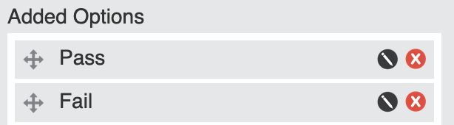
Answer options can be laid out Horizontally or Vertically and like other functions, you can decide if answering the question is mandatory and to whom it is visible to.
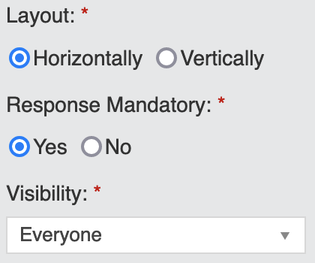
All question types can be edited after the fact by an administrator, but you can turn this off by selecting “No”.
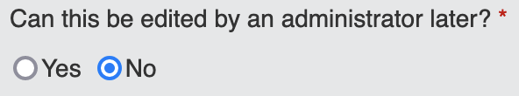

After selecting Add, your question will be added to the bottom of the form. You can use the directional arrows to drag and rearrange the question type on the page.
The Draw question type allows the user to draw in a preset field. This field can be blank, or it can have a background image that the user can draw on.
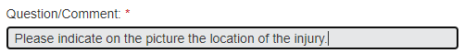
If you need to add a background image, turn this option on and attach the image file from your computer.
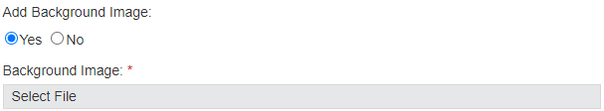
Use the Height and Width fields to determine the size of the drawing area (in pixels). Use the Alignment field to determine where the drawing area will be aligned in the report. Use the border field to set the thickness of the border around the drawing area.
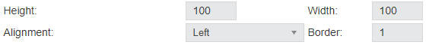
The File Upload question type gives the user the ability to upload an attachment. The instructional text will default to “Browse” but it can be customized.
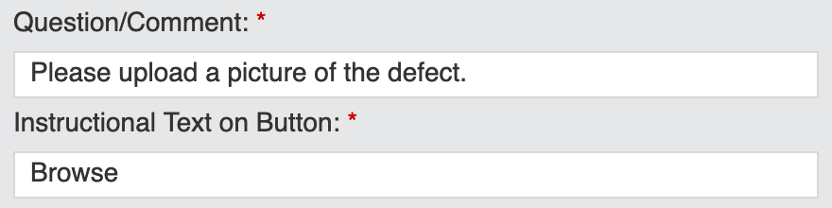
You can also choose to allow all file types to be uploaded or limit the user to a specific file type such as a PDF or word document.
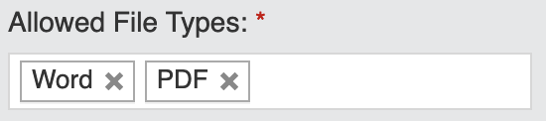
The Date question type allows you to collect the date by using a calendar picker. You can select the date style and assign if the user is allowed to leave this field “Unknown”. If you choose to allow the administrator to make changes later, this can be filled in once more information is gathered.
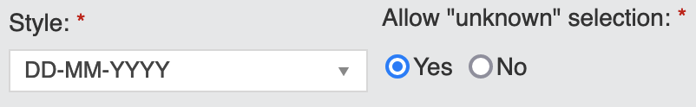
The Time question type gives you the ability to collect the time. You can select between the 12-hour or 24-hour clock and assign if the user is allowed to leave this field “Unknown”.
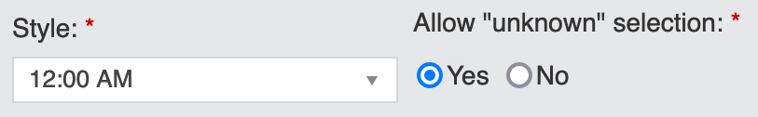
The Open question type allows you to ask a question or leave room for comment. You can restrict the field to limited characters or leave it unlimited. Open questions can be linked to Rules when adding answer options (see Open Hidden Item).
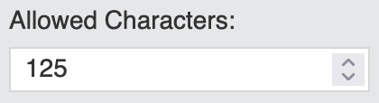

WIDGETS
This section provides ways of collecting more data or functions throughout your form. Let’s walk through each widget and their use.
Each question type is designed to collect a single field of information. The Add More widget allows you to add additional fields to a question. Select the question you would like to add this feature to and select whether the user is restricted to the number of responses.
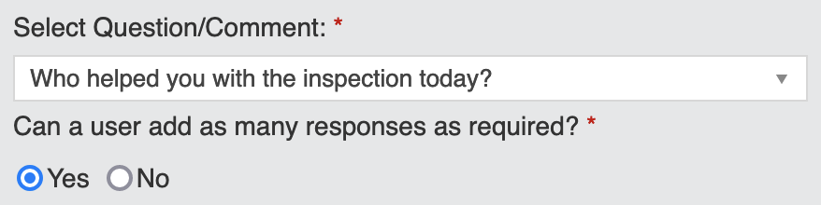
The result on the form will appear like this:
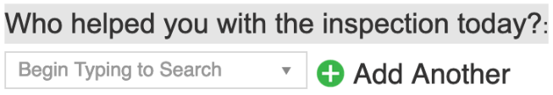
The Assign User widget allows you to add an assignable user field to a specific question. The user completing the form can then assign a specific question to a specific user, thus making it their responsibility to complete the question.
To do so, select the question you wish to add the assign user field to and if you would like to add a hint. It could be useful to provide instructions to the user on whom they should be assigning the question for completion.
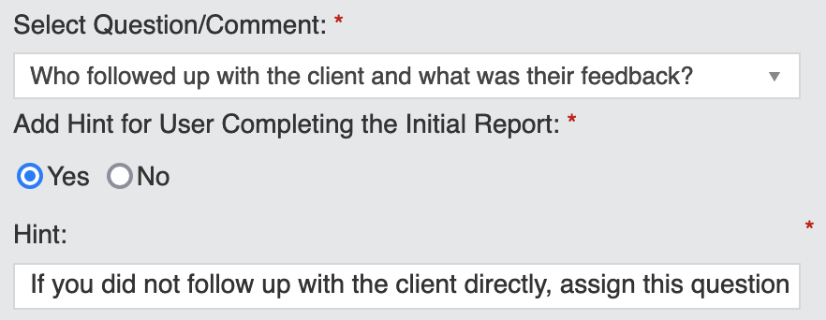
Next, choose if a due date for answering the question is required and if the assigned user can reassign the question to someone else.
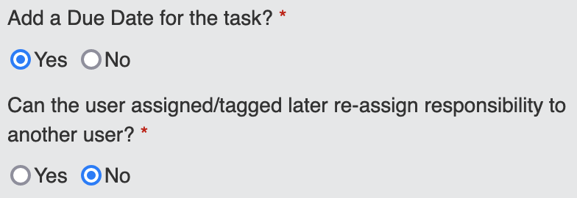
Once the assigned question has been answered, you can require a follow-up by a specific administrator to ensure the question was answered adequately.
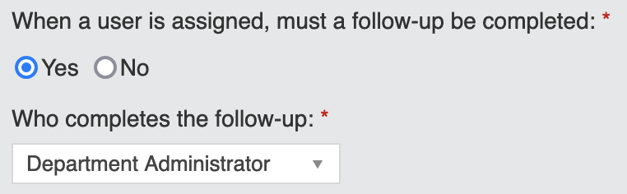
The administrator selected will be notified and then they can reassign the follow-up to another user or complete it themselves.
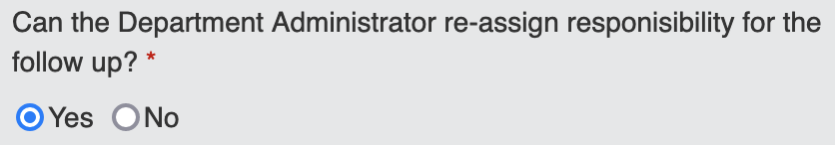
The result will appear like this:
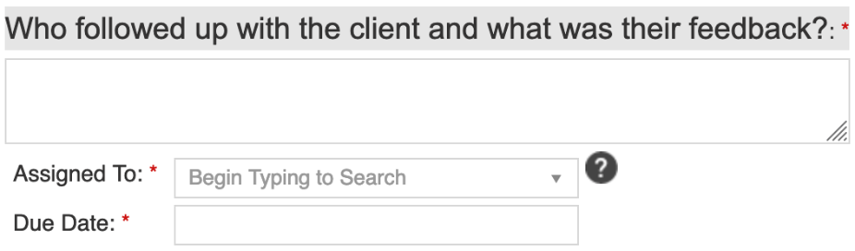
The Short-Codes widget gives you the ability to look up common short-codes and unique short-codes used in the report. You can then copy the short-code so you can include it in the report. A short-code will pull data from the system based on its reference and populate the information for you in the form.
For example, you could add an introduction to your report and use “Hello {FirstName}”. When a user is completing the report, they will see this as “Hello Mohammed.”
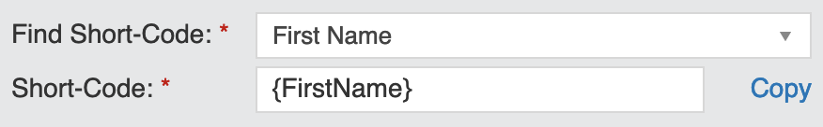
In the Find Short-Code dropdown menu, you will find all standard short-codes for system information, as well as short-codes for all form items and question types that have been added to the specific report you are creating.
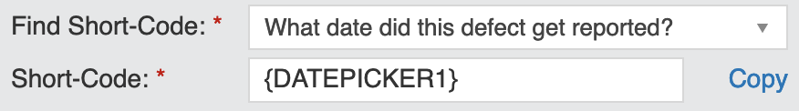
This is a great way to pull existing information into other pages or sections of the report for reference. Design your report to work for you!

Adding an Element, Form Item, Question Type or Widget
There are a variety of report tools that you can add to your report. For a breakdown of each tool, see the previous section of this user guide. Adding an element, form item, question type, or widget all functions the same way. We will use an element for this example.
To add an element, click on the element you wish to add to the report. A pop-up window will appear with any settings that relate to this tool or element. Fill out your selection and click Add.
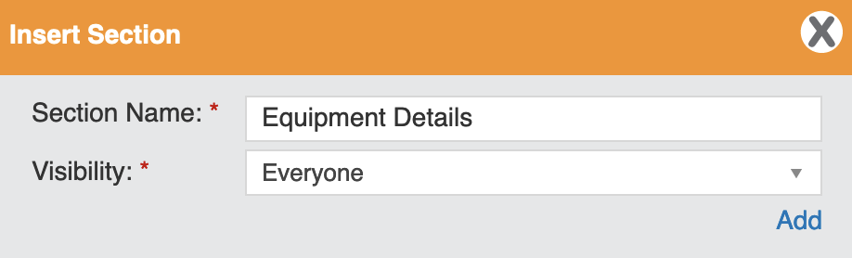
By default, any new elements, form items, question types, or widgets will be added to the bottom of your report page. To rearrange any items, see the next section.

Moving an Element, Form Item, Question Type or Widget
Any element, form item, question type, or widget can be rearranged on the page, but they cannot be moved to a different page. If you need to move a field to one of the other pages of your report, you will need to add it as a new field on the new page and delete the old one.

Next to the form field you want to move, click and drag the arrow icon. Move the field to its new location and release.

Copy an Element, Form Item, Question Type or Widget
Any element, form item, question type, or widget can be duplicated on the page. This can be a time saver if you have similar question types or elements. Duplicating the field gives you the ability to make a copy and change any settings (if necessary).

Next to the form field you want to duplicate, click the copy button. By default, the item will be added to the bottom of the page.

To make changes to the copied item, click the edit button in the field. Make any necessary changes and click Save.


Deleting an Element, Form Item, Question Type or Widget
To delete a form field, click the delete button within the field. The system will prompt you to confirm your selection.

Manage Reports
This function allows you to manage the following:
Edit Report: This allows you to make changes to an existing report. Note: You cannot make changes to a published report. If your report is in a published state, you must Unpublish it to make changes.
Preview Report: This allows you to preview the report. All fields are active so you can test them but none of the information will be saved.
Copy Report: This will duplicate a report. It will keep the same title and the system will add “- COPY” to the end of the report name.
Publish Report: This allows you to make a report accessible to users on the system.
Unpublish Report: This allows you to stop the report from being in use. Reports need to be in an unpublished state to make changes.
Report Active: When a report is active, its information is available to be mined. When administrators run a report on the Report It feature, the data will be included. If you do not want the data included in your reports, make the report inactive.
Report Inactive: When a report is inactive, its information is completely hidden from the reporting system. When administrators run reports on Report It, the data will be left out.
Delete Report: This will permanently delete the report from the system.
Let’s walk through each function in detail.

Edit a Report
Editing a report allows you to make changes to a report already added to the system. You can only make changes to a report if the report is in an unpublished state. If your report is published, you will not see this authoring option.

To get started, select the Edit Report icon located in the Authoring Options column.
First, you will be able to make any changes to your Report Settings. You can make changes to things like the report name, description, opening and final report submission message, as well as changes to the publishing frequency or to whom the report is assigned to.
After you have made your changes (if any), select Save and Continue.

Next, you will be taken to the report builder page. Make any necessary changes to the report (if any) and select Save Report.

The system will notify you the changes were saved successfully.
Note: To make your report accessible on the system, you will need to publish your report. Please see the Publish a Report section of this user guide.

Preview a Report

Previewing a report allows you to see how the report looks from a user’s perspective.
To get started, select the Preview Report icon located in the Authoring Options column. A pop-up window will appear displaying the report in its entirety.
When you are done reviewing the report. Click the Close Preview button located in the top right-hand corner of the pop-up window.
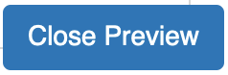

Duplicate a Report

Duplicating a report allows you to make a copy of an existing report. This is a real-time saver when you have several reports with slight differences.
To get started, select the Copy Report icon located in the Authoring Options column.
The system will automatically duplicate the report and add the extension “- COPY” to the end of the report name.
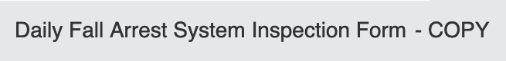

Publish a Report

Publishing a report makes it accessible on the system for users to fill out. Until this action is done, the report is hidden from the front end and is not available for submission.
To get started, select the Publish Report icon located in the Authoring Options column.
The report is now in a published state. You will notice you can no longer edit the report. A report can only be edited if it is unpublished.

Unpublish a Report
Unpublishing a report makes it hidden on the system and users are no longer able to access the report from the front end. If you need to make changes to your report this is your opportunity as you are only able to make changes to reports that are in an unpublished state.

To get started, select the Unpublish Report icon located in the Authoring Options column.
The report is now in an unpublished state. You will notice you can now edit the report under your authoring options.

Activate a Report
Reports must be active as well as publish in order to be seen by employees. If your report is currently inactive, its data is hidden in the system when running reports on the Report It feature. If you wish to run reports on a report then it must be made active.

To make a report active, select the Report Inactive icon located in the Authoring Options column.
The report is now active, and its information will be included when running reports in Report It.

Inactivate a Report
A report will be Active in the system by default. When running reports on the Report It feature, you can only pull data from active reports. If a report is inactive, it is hidden completely from system reports but still visible in Manage Reports.

To make a report inactive, select the Report Active icon located in the Authoring Options column.
The report is now inactive and hidden when running reports in Report It.


Delete a Report

Deleting a report will permanently remove the report from the system. You will not be able to undo this action.
To get started, select the Delete Report icon located in the Authoring Options column.
The system will prompt you to confirm your selection. Click delete to permanently delete your report.
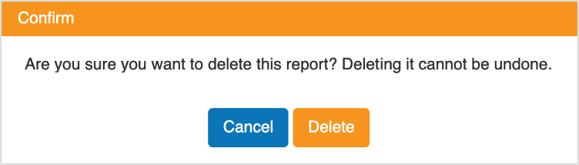
The system will notify you the report was deleted successfully.

Set-Up Equivalent Reports
Like equivalent courses, you can set up equivalent reports. For example, if you have an incident report for your company, the definition of an incident would be different for each province, but you would want to be able to pull a report based on all similar reports.
The Set-Up Equivalent Reports function allows you to link all multiple reports under one name, allowing you to later pull data on multiple reports at one time.
To get started, enter the Equivalent Name and then select all reports that apply. Note: You can only choose from reports that are Published in the system. For help, see Publish a Report.
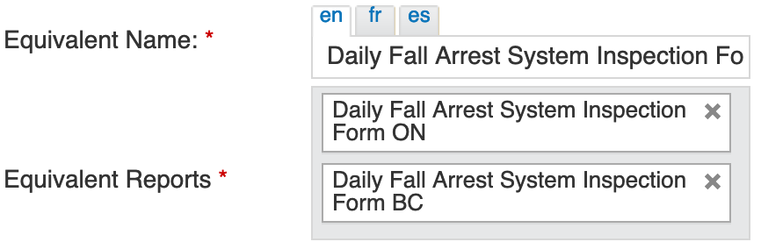
After you have made all your selections, click Add Equivalent Reports.

The system will notify you that you have successfully set up the Equivalent Reports.
If you ever need to edit your equivalent reports, you can do so using the Manage Equivalent Reports function.

Manage Equivalent Reports
Making changes to your equivalent reports is easy. Select which equivalent report you would like to edit from the dropdown menu.
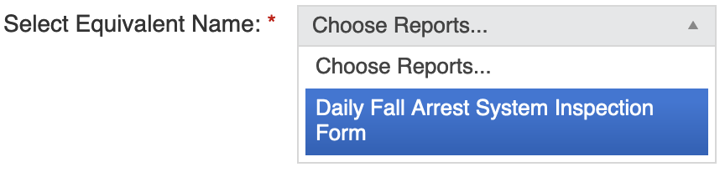
Next, you can change the name of your equivalent report and update which reports are included. To add a report, click within the grey field and choose from the list of eligible reports. Remember, your report must be published to be added to an equivalent report. To remove a report, select the ‘X’ next to the report title.
You can also change the status of your equivalent report. All reports are active by default, but you can choose to make the equivalent inactive or delete it entirely.
After you have made your changes, click the Update Equivalent Reports button.

The system will notify you the changes were successful.


Update a Report
As an administrator, you can make changes to report submissions (if enabled), and delete submitted reports from the system. To get started, select Update a Report in the Report It feature. A list of all In-progress and Completed reports will appear on the page. You can use the search filters to narrow down your results to find a specific report.
You can use the search filters to do the following:
Report Type: This allows you to filter reports based on the report type such as Health & Safety or Human Resources.
Report Name: This allows you to filter by report name. Click within the grey field and choose from the available reports.
Search: This allows you to filter using keywords. For example, if you know the unique ID assigned to the report or who completed the report, you could search by the ID number or the user’s name.
Date From and Date Until: This allows you to filter between two dates. This will show results for the Date Submitted of each report.
Status: This allows you to filter on different report statuses. The search field will default to all, but you can narrow it down by pending tasks or closed reports.
After you’ve made your selection(s) click the Search button.

Each report will display the report name, report type, who submitted the report, the date it was submitted, and the status of the report. Let’s walk through all your Authoring Options in detail.

View Summary
View Summary gives you the ability to view the report and submissions. You can also track the report history to see what answers were updated, when tasks were completed and by whom, and more.
Start by clicking on the Report Summary icon located in the Authoring Options column.
An overview of the report and submitted responses will appear at the top of the page. If the report has multiple pages, you can click on the different tabs to view each page.
Below that is Question History. If any of the responses have been updated after the report was submitted, the changes will appear here. The system will note the question, what the original response was and what it was changed to, who changed it and when.
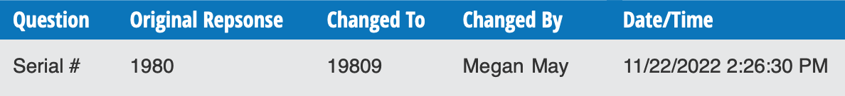
Next, is the Submission and Verification History. This provides information about when the report was submitted and verified. The system will note the state of the report when it was submitted, who submitted it and when.
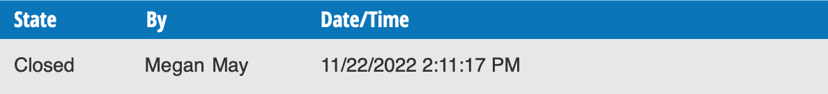
Next, is the Task History. Tasks are assigned using the Assign User widget when building a report. It is a tool used to ask a user to complete a field on a report. When those fields are completed by other users, they will appear under task history. The system will note which question was answered and the user’s response. It will also note who completed the question and the date and time.
Last is Follow-Up History. After you assign a user a task in the report, you can also request whether a follow-up is necessary and by whom. The system will note what the question was, who completed the follow-up, and when.
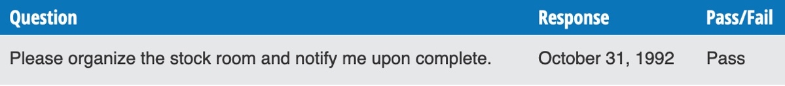
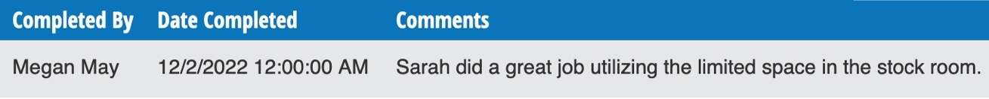

Edit Report
Sometimes things change and we get that. The Edit Report function gives you the ability to go into a submitted report and update information. This function is only available if enabled when choosing your report settings (see below).
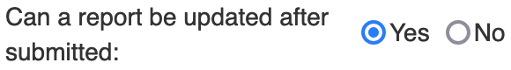
Note: If you need to enable this function on your report, see section Edit a Report in this user guide.
To make a change to a submitted report, start by finding the report you wish to edit using the Update a Report function in Report It.
Click on the Edit Report icon under the Authoring Options column.
Find the field you wish to edit and select the green edit icon next to the question.
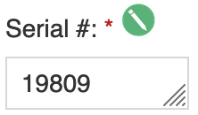
Change the information found in the field and click the Save Report button.

Changes such as these will appear in the report’s Question History. To see a list of changes made to a report, click on the View Summary button.

Delete a Submitted Report
In some cases, you may need to permanently delete a submitted report from the system.
Start by clicking on the Delete Report icon located in the Authoring Options column.
The system will prompt you to confirm your selection. Click the Delete button to permanently delete the submitted report. This action cannot be undone.
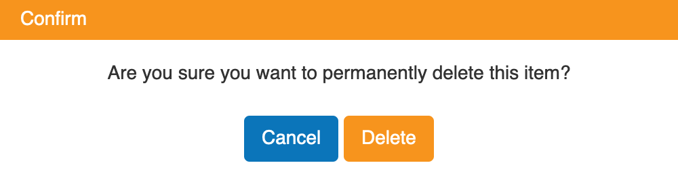
The system will notify you the report submission was successfully deleted.

Print the Report
When you are reviewing the summary of the report, you can print a hard copy for your records.
Using the Update a Report function, find the report you wish to print and click on the View Summary icon.
In the top right-hand corner of your screen, click on the Print button. Under destination, ensure your local printer is selected and click the Print button.
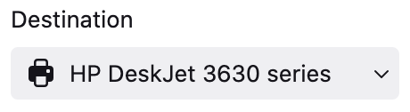

Save a PDF of the Report
When you are reviewing the summary of the report, you can use the print function to save a pdf copy of your report.
Using the Update a Report function, find the report you wish to print and click on the View Summary icon.
In the top right-hand corner of your screen, click on the Print button. Under destination, select Save to PDF and click the Save button.
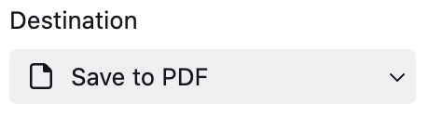

View Report Progress
The View Report Progress function gives you the ability to view the report in its current state. You can review responses and check the history of tasks and changes made to a report. To get started, click on View Report Progress in the Report It feature, under General Options.
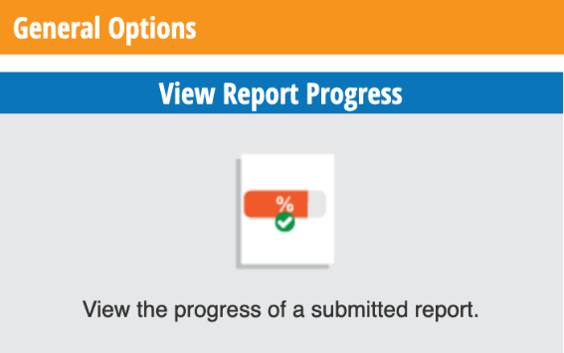
All reports in progress and completed will appear on the overview page. You can use the search filters to narrow down your search:
Department: This allows you to focus on reports in a specific department.
Employee: This will display reports completed by a specific user. This field allows for multi-select so you can add more than one user to the search.
Date From and Date Until: This allows you to filter between two dates. This will show results for the Date Submitted of each report.
Status: This allows you to filter on different report statuses. The search field will default to all, but you can narrow it down by pending tasks or closed reports.
After you’ve made your selection(s) click the Search button.
Each report will display the report name, report type, who submitted the report, the date it was submitted, the status of the report, and the user or location that the report is assigned to.
To view a report, click on the View Summary icon located in the Authoring Options column.
An overview of the report and submitted responses will appear at the top of the page. If the report has multiple pages, you can click on the different tabs to view each page.
Below that is Question History. If any of the responses have been updated after the report was submitted, the changes will appear here. The system will note the question, what the original response was and what it was changed to, who changed it and when.
Next, is the Submission and Verification History. This provides information about when the report was submitted and verified. The system will note the state of the report when it was submitted, who submitted it and when.
Next, is the Task History. Tasks are assigned using the Assign User widget when building a report. It is a tool used to ask a user to complete a field on a report. When those fields are completed by other users, they will appear under task history. The system will note which question was answered and the user’s response. It will also note who completed the question and the date and time.
Last is Follow-Up History. After you assign a user a task in the report, you can also request whether a follow-up is necessary and by whom. The system will note what the question was, who completed the follow-up and when.

Complete Pending Items
As an administrator, you may need to follow up on a specific question in a report or verify a report when it’s completed. These decisions are made while setting up the initial report in Build a Report.
To get started, select Complete Pending Items which can be found in the General Options section of Report It. On the overview page, you will see a list of pending items. Each report tells you who submitted the report, the date it was submitted, the action item that is asked of you, and its due date. Refer to the Action Item column to find out what the pending item is for each report.
Assigned Task(s): This means there are questions within the report that you are required to answer.
Task Follow-Up: This means another user answered a question in the report that requires your review. To complete this action, follow the steps below.
Verify Report: This means you must review a submitted report and give the final sign-off.
Let’s walk through each Action Item in more detail.

Complete an Assigned Task
You’ve been assigned a task, let’s complete it.
To get started, select the Complete Task icon located in the Authoring Options column.
You will be taken to the Task Assignment located within the report.
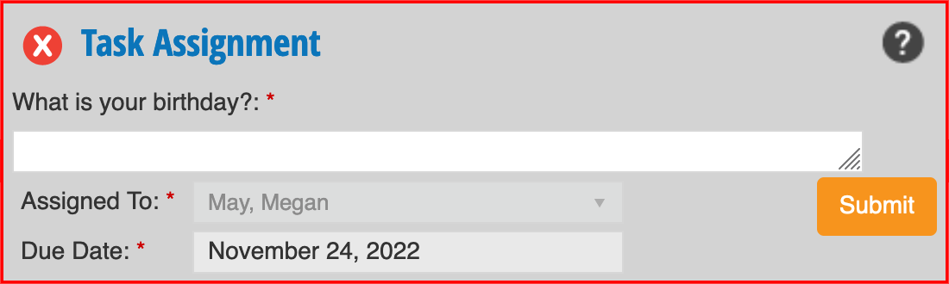
Complete the task and select the Submit button.
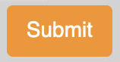
The system will ask you to confirm your answer. Select the Submit button if the information is correct.
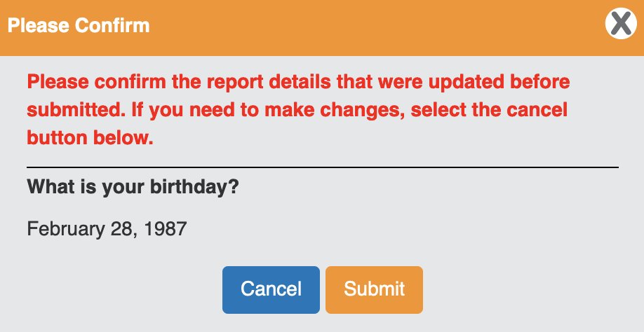
If you are required to complete more than one assigned task within the report, you will be taken to the next task. Once you answer the last task assigned within the report, you will be redirected to the Complete Pending Items overview page.

Complete a Task Follow-Up
You’re required to complete a task follow-up. Let’s complete it.
Select the Complete Task icon located in the Authoring Options column.
You will be taken directly to the question that requires a follow-up. Review the user's response and answer the questions.
In this example, the user was required to organize the stock room. Did you complete a follow-up to ensure the task was completed properly? If so, which day did you complete the follow-up and was the task completed successfully?
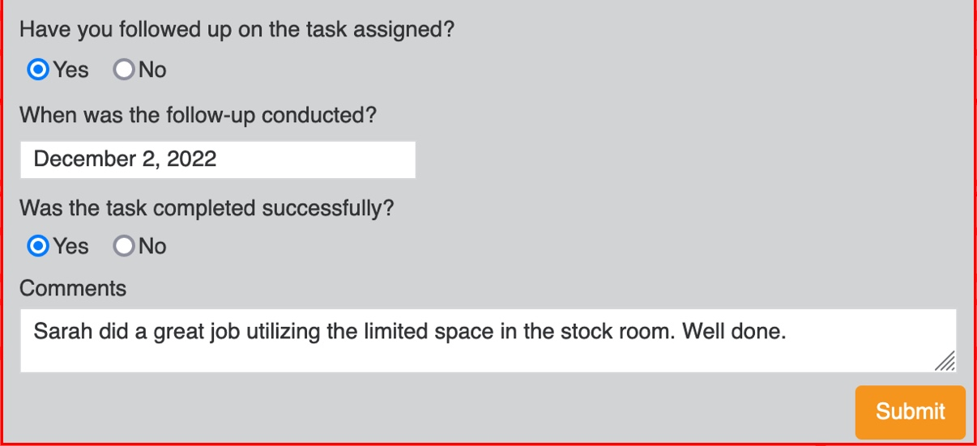
Once you are done, select the Submit button. The system will ask you to review and confirm your responses.
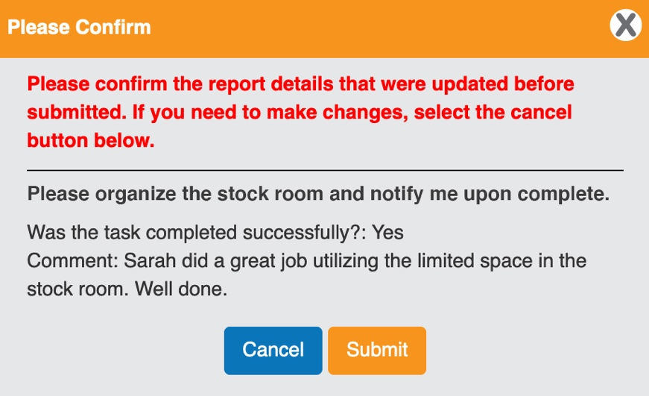
If there are no other task follow-ups within the report, you will be redirected to the Complete Pending Items overview page.

Verify a Report
You’re required to verify a report. Let’s complete it.
Select the Complete Task icon located in the Authoring Options column.
You will see the report in its entirety with all answer options. While setting up the report, if it was permitted for the administrator to revise any answers, then you will be able to do so. If this feature was turned off, then the field will be locked.
To make a revision to the report, select the green edit icon located next to the question you wish to update.
The field is now active. Make your changes and then click the Save Report button.
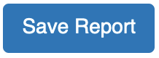
The system will notify you that your changes were saved successfully. Continue your review by selecting the Save and Continue button. Once you have completed your review, you will be required to confirm the report details – this is your final sign-off.
Select the Submit Report button to complete the review process.


Manage Employee Injury Status
As an administrator, you can manage an employee’s injury status using Report It. The Manage Employee Injury Status function allows you to add an employee’s injury, track modified duties and lost time, and record when an employee has fully returned to work.
Let’s get started by clicking on Manage Employee Injury Status found in Report It.
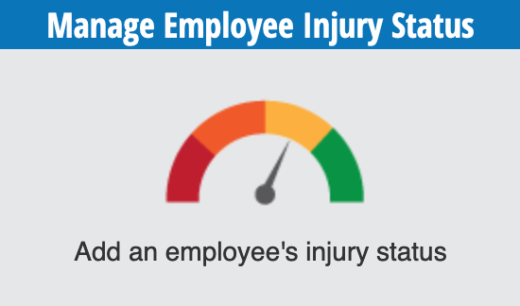
This will bring you to the overview page where you can see information for the following:
Employees Pending Confirmation: This section will display any employees who are awaiting confirmation of their injuries and a return to work plan.
Employees with Active Lost-Time or Modified Duties: This section displays all employees who are currently on modified duties or lost time due to injury.
Employees with Full Return to Work: This section displays all employees who have returned to full work.
Use the search filters found at the top of the page to quickly find a specific employee. You can search by department, employee, or injury status.
Let’s start by adding an employee and then we will dive into each stage of the return-to-work process.

Add an Injured Employee
There are cases where you will need to manually add an injured employee, for example, if an injury took place before you started using Report It.
To add an injured employee, select the Add Employee button found in the top right-hand corner of the overview page.
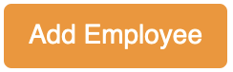
Select the department for the injured employee and then use the dropdown menu to select the injured employee. Next, select if the employee is on modified duties, lost time, or had a full return to work.
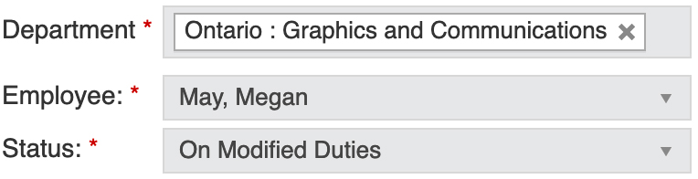
Note: If you select on Modified Duties then it is mandatory to fill in a Modified/Light Duties Start and End Date. If you select on Lost-Time then it is mandatory to fill in a Lost-Time Start and End Date.
Use the calendar picker to fill in the dates for the respective field that matches the employee’s status.
The Total Number of Modified Days will auto-fill based on your selection above. This will only include calendar days. In our example, the employee will be on modified duties for 6 days.
Next, we will add the modified work the employee will be on. Select the Add Duty icon found under the Remove/End Duty column.

Add the Description of Duty. The Date Assigned will auto-fill to today’s date but if you are adding this information in retroactive then select the date the modified duty was assigned.
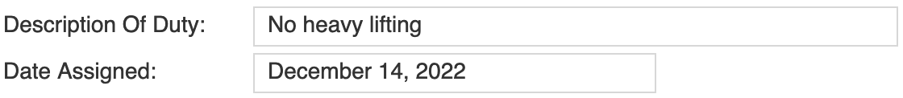
Select the Add button and the modified duties chart will update. To save the employee information, select the Update button in the bottom right-hand corner. The system will notify you that your employee’s injury was successfully updated.
You will be brought back to the overview page and the employee will appear under Employees with Active Lost-Time or Modified Duties or Employees with Full Return to Work (depending on the information recorded).

Update an Employee’s Injury Status
As an employee moves through the return-to-work process you will need to update their injury status.
To do this, select the Update Status icon in the authoring options column.
Select the Edit icon next to any fields you wish to change and update the information.
In our example, the employee is returning to full work as per their doctor’s instructions.
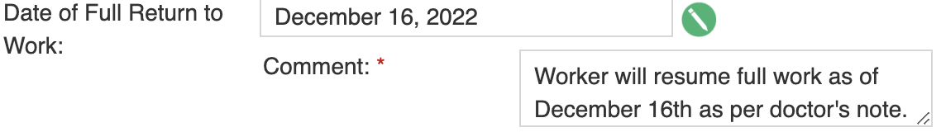
After you have made all your updates, select the Update button.

The system will return you to the overview page and notify you that your changes were successfully saved.

Confirm an Employee’s Injury Status
If an employee injury has been reported by submitting the corresponding form under the Report It, the completed form will be listed under Employees Pending Confirmation.
This section indicates the name, Report ID, and date of the submitted form, as well as the name of the employee that submitted the form.
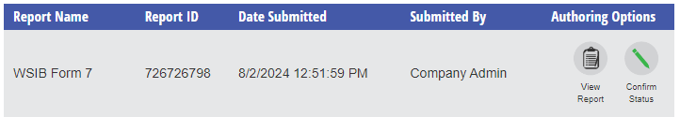
To confirm the employee’s injury status, select the Confirm Status icon in the authoring options column.
On the Confirm Status page, confirm the name of the injured employee. The Injured Employee defaults to the employee who submitted the report. This will need to be updated to the name of the injured employee.
Next, select if the employee is on modified duties, lost time, or had a full return to work.
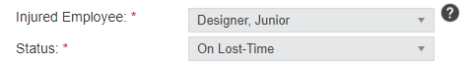
Note: If you select on Modified Duties then it is mandatory to fill in a Modified/Light Duties Start and End Date. If you select on Lost-Time then it is mandatory to fill in a Lost-Time Start and End Date.
Use the calendar picker to fill in the dates for the respective field that matches the employee’s status.
The Total Number of Modified Days will auto-fill based on your selection above. This will only include calendar days. In our example, the employee will be on modified duties for 6 days.
Next, we will add the modified work the employee will be on. Select the Add Duty icon found under the Remove/End Duty column.
Add the Description of Duty. The Date Assigned will auto-fill to today’s date but if you are adding this information in retroactive then select the date the modified duty was assigned.
Select the Add button and the modified duties chart will update. To save the employee information, select the Update button in the bottom right-hand corner. The system will notify you that your employee’s injury was successfully updated.
You will be brought back to the overview page and the employee will appear under Employees with Active Lost-Time or Modified Duties or Employees with Full Return to Work (depending on the information recorded).

