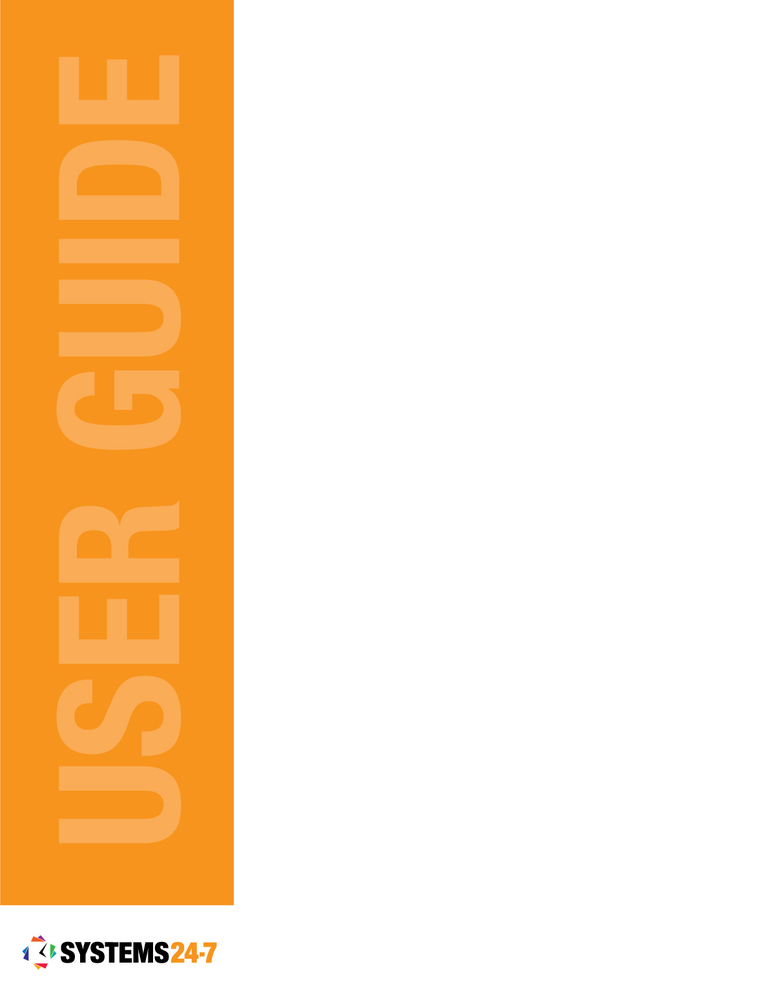
Report It
Basic User Guide

Table of Contents
Submitting a Report 3
Continue a Saved Report 5
Complete Pending Items 6
View Summary 6
Complete a Task 7
Re-assign a Task 8
View Report Progress 9
Print a Report 11
Save a PDF of the Report 11

Report It is a feature where your organization can create custom reports. These can include anything from daily a checklist to a detailed inspection form. Individual elements on a form can be assigned to other users for completion and all responses and changes are tracked through Systems 24-7.
To access Report It, select the Report It icon from the navigation menu located on the left-hand side of your website.
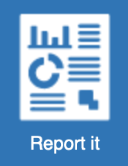
Under General Options, you will have the ability to submit a new report, continue a saved report, complete a pending item, and view the progress of a report.
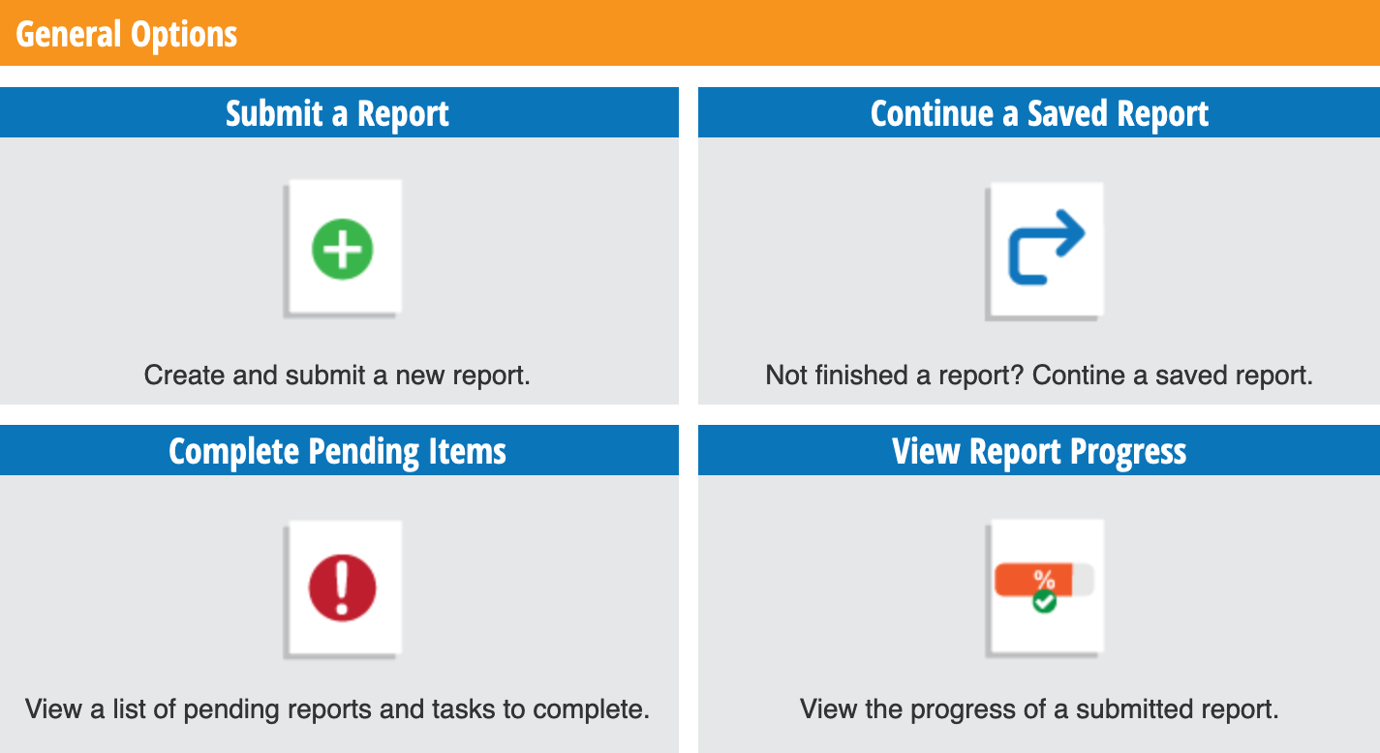
Let’s start with submitting a report and we will work our way through the other functions of the Report It feature.

Submitting a Report
So, it’s time to submit a report? The first step is finding the report you need to submit. In Report It, click on Submit a Report.
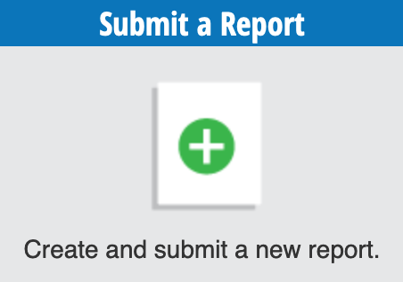
Reports are broken out by Report Type (categories). To view the reports available within each category, click on the applicable tab located across the top of your screen.
Once you have found the report you are looking for, click on the Begin Report button.

Reports can range from one page to multiple pages. You can refer to the progress bar across the top of the page to see how far along you are in the report.
While completing your report you can save where you are at and continue the report later. A page can be incomplete with required fields, and the system will allow you to save your spot and return at any point.
Look for the Save Report button located at the top and bottom of the report.

The system will notify you the report has been saved and you can access this report using the Continue a Report option on the Report It page.
To complete the report, fill in all the required fields and select the Save and Continue button.

Required fields are mandatory and must be answered to continue. They are marked with a red asterisk* and are important information to the report. If any of these fields are missing responses, the system will notify you and you will be required to complete them before moving on to the next page.
As you move through your report, you will have the option to go back and make changes if necessary. To do this, click the Go Back button located in the bottom left-hand corner of the report page.

Once you have completed the report, you will be required to review and confirm the report details are correct. If you see a mistake, use the Go Back button to revise your response. After you have completed your review, click the Submit Report button.

If the report is set up to be saved to your current location, and your account is under multiple locations, the system will prompt you to select the location to save it under.
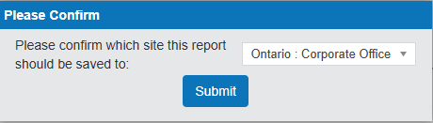
The system will provide you with a final confirmation that your report was submitted successfully. To complete another report, select the Return to Report It button.


Continue a Saved Report
If you had to leave a report unfinished and you’re ready to complete the report, click on the Continue a Saved Report option.
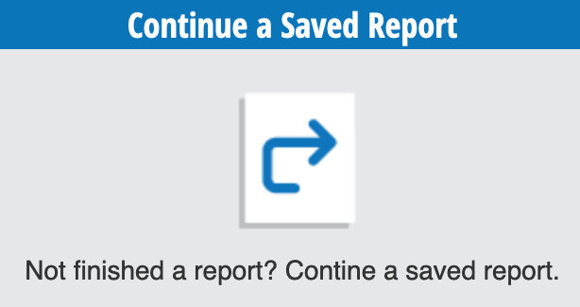
All incomplete saved reports will appear on the overview page. Each report will have a date and time stamp for when the report was originally started and when it was last updated.

To continue a report, select the Continue Report icon located in the Authoring Options column.
The report will take you to where you left off. Finish completing the report and click the Save and Continue button.

Once you have completed the report, you will be required to review and confirm the report details are correct. If you see a mistake, use the Go Back button to revise your response.
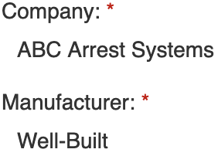
After you have completed your review, click the Submit Report button.
The system will provide you with a final confirmation that your report was submitted successfully. To complete another report, select the Return to Report It button.

Complete Pending Items
When your organization is building a report, they can assign required information within a report to a specific user to complete. You will find all these requests under Complete Pending Items. To access your pending items, select the Complete Pending Items option in Report It.
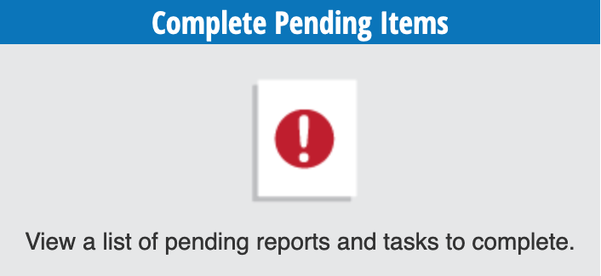
All your pending items will appear on the overview page. Each report will be listed and display who submitted the report, what is required of you (assigned task), and the task due date.
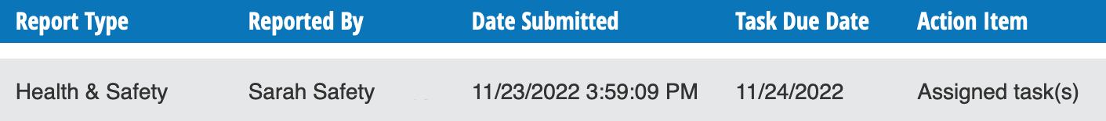

View Summary

Before you complete a pending task, it is a good idea to review the report to refresh your memory or get a better understanding of what the report is about.
To do this, select the View Summary icon located in the Authoring Options column.
An overview of the report and submitted responses will appear at the top of the page. If the report has multiple pages, you can click on the different tabs to view each page.
Below that is Question History. When changes are made to a report, they will be listed here. The system will note the question, what the original response was and what it was changed to, who changed it and when.
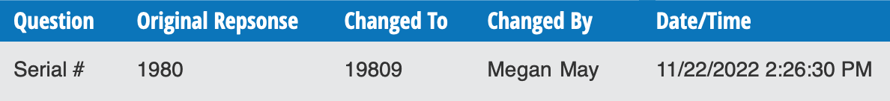
Next, is the Submission and Verification History. This provides information about when the report was submitted and verified. The system will note the state of the report when it was submitted, who submitted it and when.
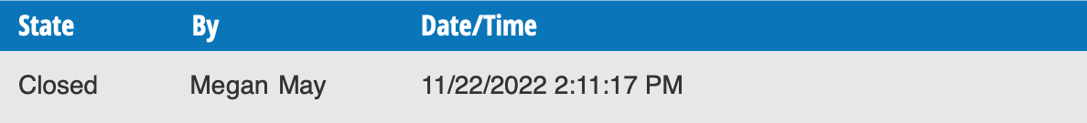
Next, is the Task History. All tasks completed by other users will appear under task history. The system will note which question was answered and the user’s response. It will also note who completed the question and the date and time.
Last is Follow-Up History. After you assign a user a task in the report, you can also request whether a follow-up is necessary and by whom. The system will note what the question was, who completed the follow-up and when.
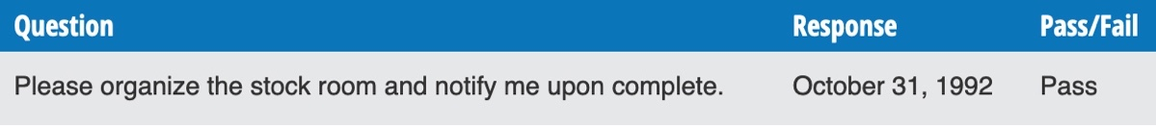
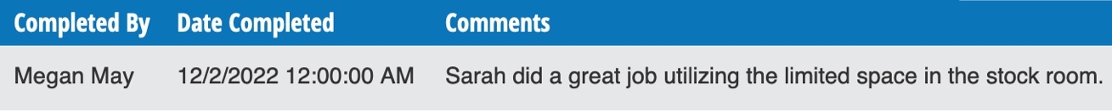

Complete a Task
You’ve been assigned a task, let’s complete it.
To get started, select the Complete Task icon located in the Authoring Options column.
You will be taken to the Task Assignment located within the report.
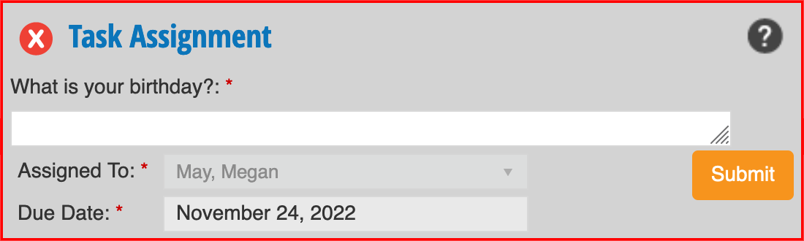
Complete the task and select the Submit button.

The system will ask you to confirm your answer. Select the Submit button if the information is correct.
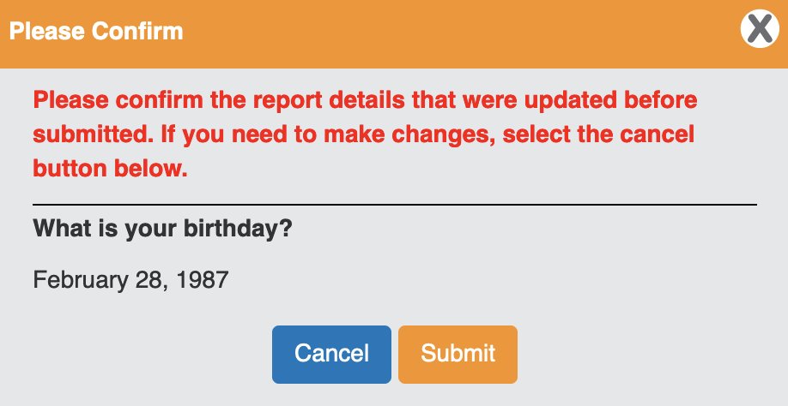
If you are required to complete more than one assigned task within the report, you will see notifications on the different pages of the report that require your attention.

Complete all required tasks. Once you’ve answered all your assigned tasks, you will be redirected to the Complete Pending Items overview page.
If you have completed all your pending items, the overview page will say “No pending items to display”.
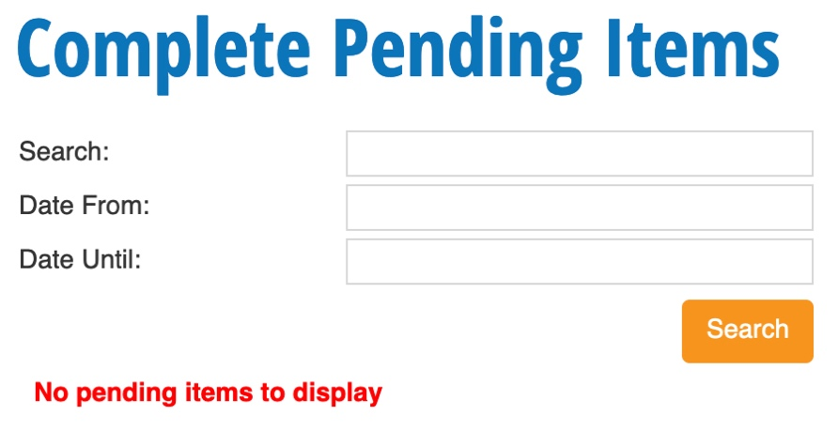

Re-assign a Task

In some cases, you will be given the ability to re-assign a task to another user. This function can be helpful if the report requires information from more than one person. If you are unable to answer the question, you can re-assign it to someone who can.
To get started, select the Re-assign Task icon located in the Authoring Options column.
A pop-up window will appear with the task that you are re-assigning. Select whom you want to re-assign the task to by using the dropdown menu. Click the Save button to complete the action
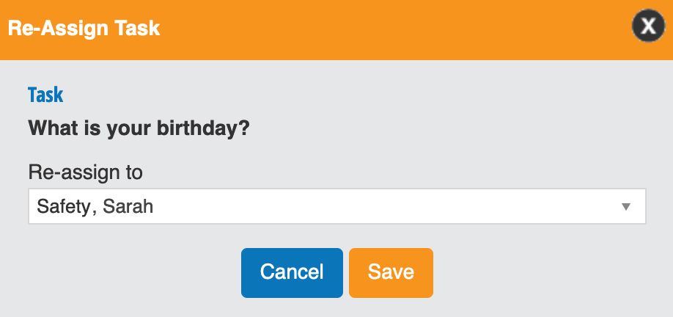

View Report Progress
The View Report Progress function gives you the ability to view all your incomplete and completed reports. You can review responses and check the history of tasks and changes made to your reports. To access your reports, select the View report Progress option.
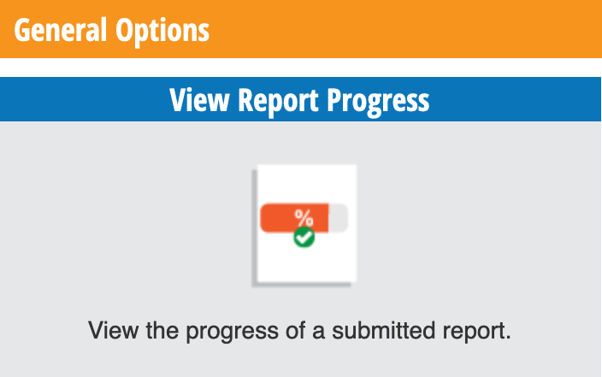
All in-progress and completed reports will appear on the overview page. You can use the search filters to narrow down your search. The filters you see will depend on your company-level permissions. Here is a breakdown of the search filters:
Department: This allows you to focus on reports in a specific department.
Employee: This will display reports completed by a specific user. This field allows for multi-select so you can add more than one user to the search.
Date From and Date Until: This allows you to filter between two dates. This will show results for the Date Submitted of each report.
Status: This allows you to filter on different report statuses. The search field will default to all, but you can narrow it down by pending tasks or closed reports.
After you’ve made your selection(s) click the Search button.

Each report will display the report name, report type, who submitted the report, the date it was submitted, and the status of the report.
To view a report, click on the View Summary icon located in the Authoring Options column.
An overview of your report and submitted responses will appear at the top of the page. If the report has multiple pages, you can click on the different tabs to view each page.
Below that is Question History. When changes are made to a report, they will be listed here. The system will note the question, what the original response was and what it was changed to, who changed it and when.
Next, is the Submission and Verification History. This provides information about when the report was submitted and verified. The system will note the state of the report when it was submitted, who submitted it and when.
Next, is the Task History. Tasks are assigned using the Assign User widget when building a report. It is a tool used to ask a user to complete a field on a report. When those fields are completed by other users, they will appear under task history. The system will note which question was answered and the user’s response. It will also note who completed the question and the date and time.
Last is Follow-Up History. After you assign a user a task in the report, you can also request whether a follow-up is necessary and by whom. The system will note what the question was, who completed the follow-up and when.
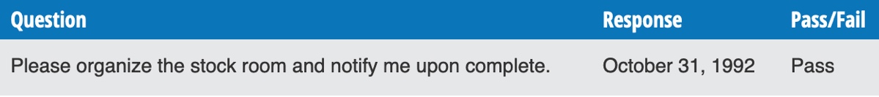

Print a Report
When you are reviewing the summary of your report, you can print a hard copy for your records.
Using the View Report Progress function, find the report you wish to print and click on the View Summary icon.
In the top right-hand corner of your screen, click on the Print button. Under destination, ensure your local printer is selected and click the Print button.
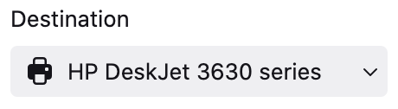

Save a PDF of the Report
When you are reviewing the summary of your report, you can use the print function to save a pdf copy of your report.
Using the View Report Progress function, find the report you wish to print and click on the View Summary icon.
In the top right-hand corner of your screen, click on the Print button. Under destination, select Save to PDF and click the Save button.
